# SRS - Nick

## Use Case Diagram – Nick

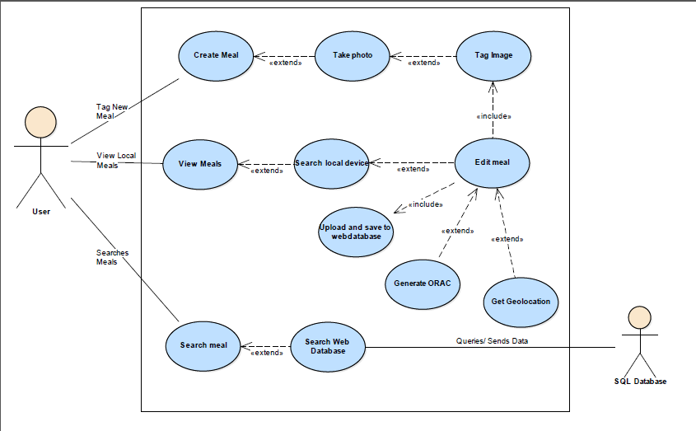

## Use Case Descriptions – Nick

|  |  |  |
| --- | --- | --- |
| **Project** |  | |
| **Use Case** | **Tag New Meal** | |
| **System** |  | |
| **Actors** | **User** | |
| **Goal**  <a longer statement of the goal in context if needed> | To Create a meal | |
| **Trigger**  <the action upon the system that starts use case> | The user selects Tag New Meal | |
| **Preconditions**  <what we expect is already the state of the world> | 1. The user has sufficient storage 2. The user has a phone with a functional camera 3. The user is in front of a meal | |
| **Success End Condition**  <the state of the world upon successful completion> | A new meal is saved | |
| **Failed End Condition**  <the state of the world if goal abandoned> | A meal is not fully created or is aborted before saving of meal | |
| **Primary Actors;**  **Secondary Actors** | User | |
| **Description / Main Success Scenario**  <the steps of the scenario from trigger to goal delivery and any clean up after. Indicate sub steps using numbering> | **Step** | **Action** |
| 1.a | App is open |
| 1.b | User selects Tag new meal |
|  |  |
|  | |
|  |  |
| **Alternative Flows**  <a: condition causing branching>  <a1: action or name of sub use case> | **Step** |  |
| 1 | **Branching** |
|  | A1 | Camera application opens |
|  |  | Image is taken |
|  | A2 | User selects meal from gallery |
|  | A3 | **Branching** |
|  |  | Image is saved |
|  |  | Image is tagged by user |
|  | 1.c | Tagged image is saved |
|  | 1.d | Meal is created |
|  |  |  |
|  |  |  |

|  |  |  |
| --- | --- | --- |
| **Project** |  | |
| **Use Case** | **View Local Meals** | |
| **System** |  | |
| **Actors** | **User** | |
| **Goal**  <a longer statement of the goal in context if needed> | User is able to view their locally saved meals | |
| **Trigger**  <the action upon the system that starts use case> | The user selects View Meals | |
| **Preconditions**  <what we expect is already the state of the world> | 1. The user has 1 or more locally saved meal(s) | |
| **Success End Condition**  <the state of the world upon successful completion> | The user views locally saved meals on their mobile | |
| **Failed End Condition**  <the state of the world if goal abandoned> | The user is unable to view locally saved meals | |
| **Primary Actors;**  **Secondary Actors** | User | |
| **Description / Main Success Scenario**  <the steps of the scenario from trigger to goal delivery and any clean up after. Indicate sub steps using numbering> | **Step** | **Action** |
| 1.a | The User selects View Meals |
| 1.b | The application then searches the local device |
| 1.c | The application then returns all locally saved meals |
| 1.d | The locally saved meals are viewed |
|  |  |
|  |  |
|  |  |
| **Alternative Flows**  <a: condition causing branching>  <a1: action or name of sub use case> | **Step** | **Branching** |
| a | The user selects edit meal on an open meal |
| A1 | The user then uploads and saves to web database |
| A1.1 | The application gets the geolocation for the image and ads it to the tags |
| A2 | The user generates the ORAC rating for the meal selected |
|  |  |

|  |  |  |
| --- | --- | --- |
| **Project** |  | |
| **Use Case** | **Searches Meals** | |
| **System** |  | |
| **Actors** | **Application** | |
| **Goal**  <a longer statement of the goal in context if needed> | The user searches the web database for Meals according to User selected tags | |
| **Trigger**  <the action upon the system that starts use case> | The user selects Search Meal | |
| **Preconditions**  <what we expect is already the state of the world> | 1. The mobile must have internet connection 2. The user must have selected to let the application use mobile data | |
| **Success End Condition**  <the state of the world upon successful completion> | A list of meals, along with individual meals is viewed by the user, according to their preferences. | |
| **Failed End Condition**  <the state of the world if goal abandoned> | No meals are viewed by the user | |
| **Primary Actors;**  **Secondary Actors** | Application  User | |
| **Description / Main Success Scenario**  <the steps of the scenario from trigger to goal delivery and any clean up after. Indicate sub steps using numbering> | **Step** | **Action** |
| 1.a | The user selects Search Meal |
| 1.b | User then selects what they want to filter by |
| 1.c | The application sends a query to the web database to view all matches |
| 1.d | The SQL database then returns the query |
| 1.e | The query results are displayed by the application |
|  |  |
|  |  |
| **Alternative Flows**  <a: condition causing branching>  <a1: action or name of sub use case> | **Step** |  |
|  |  |

## System Design

### System Architecture - Dan

### Storage/Persistent Data Strategy - Dan

### Trade-offs and Choices - Dan

### Concurrent Processes - Dan

### Package Diagram – James, Jacob

## User Interface Layouts – Nick

From Home Page – Tagging- Saved Meal

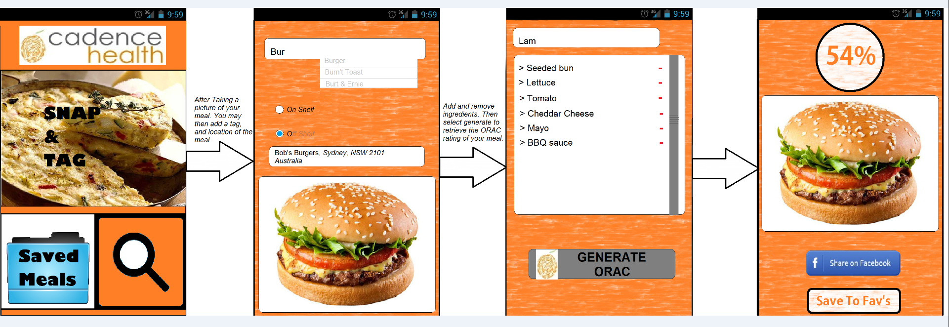

From Home Page – Saved Meals – Individual Meal

Cadence Health

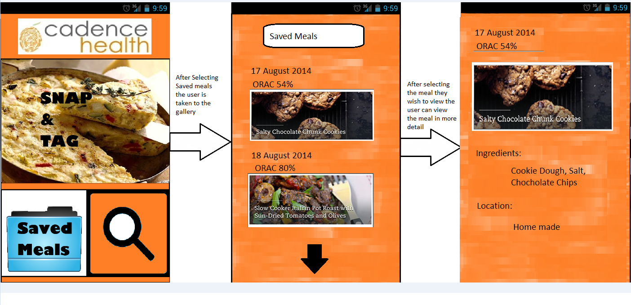

From Home Page – Search Meal

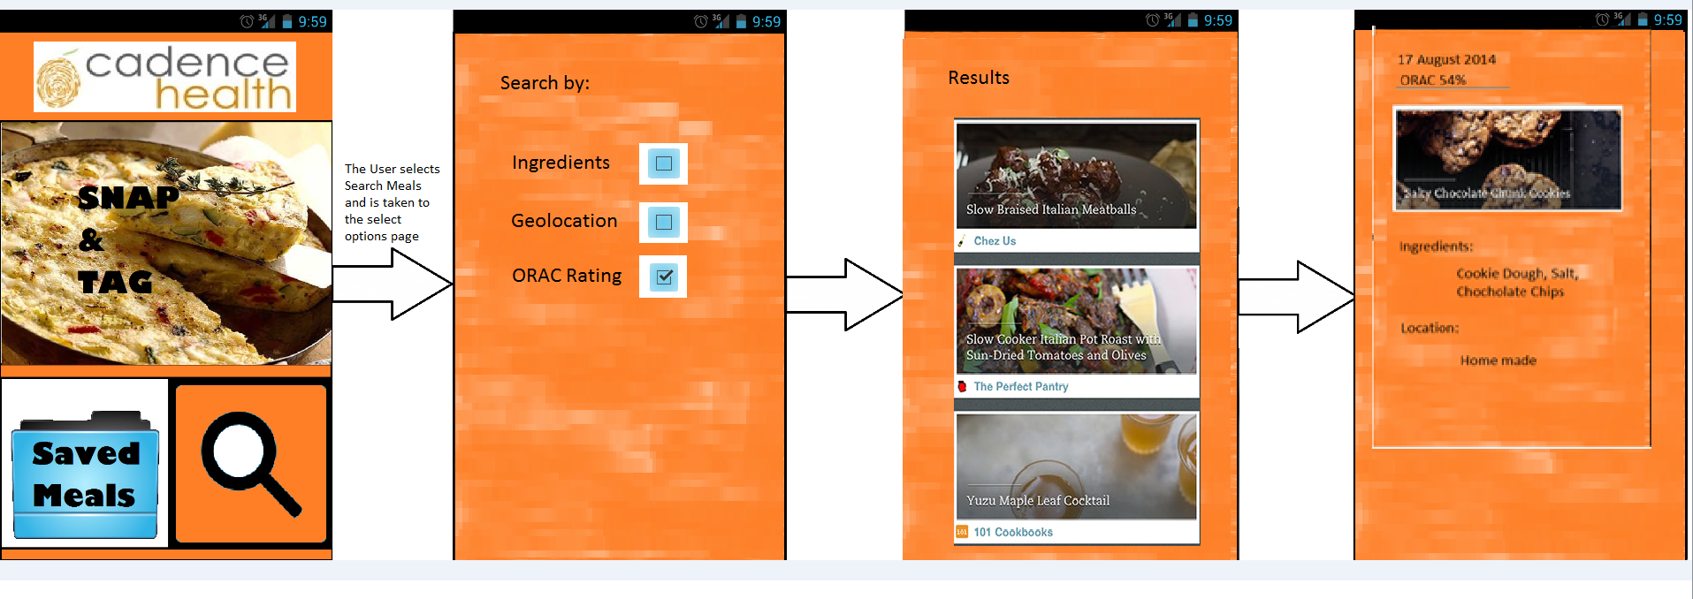

## Program Navigation Diagram – Nick

User going from Home page through to a completed meal being saved

User going from Home page through to a saved meal being viewed

User going from Home page through to a saved meal on webserver

## Data Definitions - Dan

## Analysis and Design Class Diagram – James, Jacob

## Sequence Diagram – James, Jacob

## State Diagram – James, Jacob

## Requirements Traceability Matrix – Nick

## Design Assumptions - Dan